FIRST NAME | BHUVANESHWARI.P | 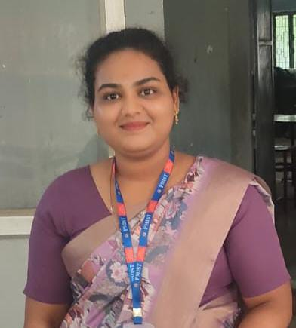
DATEOF BIRTH (DD-MON-YY) | 20.02.2000
FACULTY UNIQUE ID | 3506
UG DEGREE | B. Tech (CSE)
PG DEGREE | M.Tech (CYBER SECURITY)
DOCTRATE DEGREE | -
TEACHING EXPERIENCE | FRESHER
RESEARCH EXPERIENCE | ---
WORK EXPERIENCE | ---
OTHER EXPERIENCE | --
AREA OF SPECIALIZATION | Networking, Penetration testing, Cryptography, Ethical hacking tools handling, Malware analysis, Database security, Data Analytics, AWS and Devops
TEACHING FOR UG | FRESHER
TEACHING FOR PG | -
TEACHINGFORDIPLOMA | FRESHER
NO OF PUBLICATIONS IN NATIONAL JOURNAL
NO OF PUBLICATIONS IN NATIONAL CONFERENCE
NO OF PUBLICATIONS IN INTERNATIONAL JOURNAL | --
NO OF PUBLICATIONS IN INTERNATIONAL  CONFERENCE | 1
NO OF PG PROJECT GUIDED | --
NO OF DOCTRATE STUDENTS GUIDED | -----
PROJECTS CARRIED OUT | ---
PATENTS | -----
TECHNOLOGY TRANSFER | ------
RESEARCH PUBLICATION | ---
NO OF BOOKS PUBLISHED WITH DETAILS | ---

